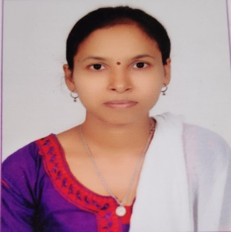

* **Course Completion Certificate Python full stack developer.**

***CERTIFICATES***

* ***Assistance Engineer.***

TNMR Projects.

07/2018 to 09/2019. Vijayawada.

* ***Cashier.***

LIC Office.

12/2019 to 12/2020. Sattenapalli.

***WORK EXPERIENCE***

***EDUCATION***

* ***B. tech (CSE) Computer Science.***

Eswar collage of Engineering.

JNTU(Kakinada).

04/2018 passed out. 78.00 CGPA.

* ***Intermediate.***

Krishnaveni junior collage.

05/2014 passed out. 75.9 CGPA.

* ***10th Class.***

Z.P.G.H School.

05/2012 passed out. 8.7 CGPA.

* Reading books.
* Travelling.
* Learn new things from news channels.
* Spend older peoples.
* Hard working nature.

***INTERESTS***

* ***Telugu***

Full Professional Proficiency

* ***English***

Full Professional Proficiency

* ***Hindi***

Professional working Proficiency

***LANGUAGES***

* Communication skills.
* Quick learner.
* Problem solving skills.
* Python full stack developer.
* MySQL.
* MS Word.
* MS Excel

***SKILLS***

*Ramyamounika*

Computer Science Student

**ramyamounika14@gmail.com**



 **9640883224**

**16-8-34,vaddavalli, Sattenapalli**.